Scavenger Hunt: Learn All About the Weather!

Hello, young scientists!

Your task is to go on a scavenger hunt to learn all about weather–from snowflakes to firestorms, to hurricanes and many things in between! In this activity, you will adventure between articles on the NOAA SciJinks website, learning all about Earth’s many weather phenomena and gathering the missing words or phrases needed to assemble your secret word.
All About Precipitation!
When you see rain or snow fall from above, you are watching precipitation in action! Follow this link to learn all about precipitation and to find the missing word:
Go to: What Is Precipitation?

Answer 1: When gas cools and turns to liquid water or ice, it is called _______.

All About Snowflakes!
Snow is not simply a frozen droplet of water falling from a cloud. What makes a snowflake different is that it forms slowly, and that it grows in the cloud. But, how exactly does a snowflake form? Learn all about it in the following article and fill in the missing word below! Go to: How Do Snowflakes Form?

Answer 2: Snowflakes form when water vapor travels through the air and condenses on a _____.

All About Tornadoes!
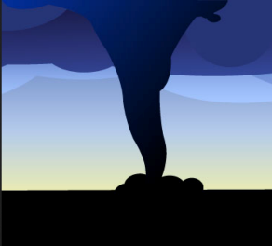
A strong tornado’s winds can pick up massive objects like trucks and drop them many miles away. It is difficult to measure the winds in a tornado directly, though. Because of this, tornadoes are evaluated by the amount of damage they cause. What tool do meteorologists use to measure the intensity of a tornado? Follow the link to find out and fill in the missing word below! Go to: Tornadoes
Answer 3: The ______ ______ scale is a tool meteorologists use to measure the intensity of a tornado based on damage.

All About Firestorms!
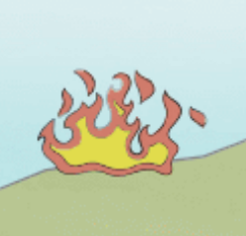
A firestorm is a phenomenon that can lead to very strange weather effects. How do firestorms occur and what do they do? Follow the link to find out and fill in the missing word below!
Go to: Firestorm

Answer 4: A firestorm occurs when ____ from a wildfire creates its own wind system.

All About Clouds!
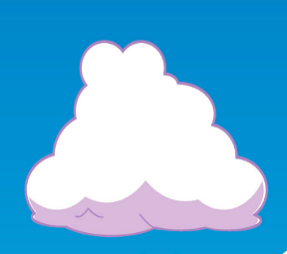
All clouds are made up of basically the same thing: water droplets or ice crystals that float in the sky. But all clouds look a little bit different from one another and they each have their own unique names. Follow the link to learn more about cloud types and fill in the blank below! Go to: Types of Clouds

Answer 5: _____ clouds appear to be made up of many small rows of fluffy ripples and have several patchy white or gray layers.

How to Read a Weather Map!
A weather map can be confusing to understand. At times, meteorologists might use a map that looks like a jumble of Hs, Ls and swirling lines. What exactly do those symbols represent? Follow the link to learn how to read a weather map and to find the word that fits in the blank below!
Go to: How to Read a Weather Map

Answer 6: A ____ _____is the transition area where a mass of cold air moves in to replace a mass of warm air. On a weather map, it is usually drawn using a solid blue line with triangles pointing in the direction of the warm air that will be replaced.

All About the Jet Stream!
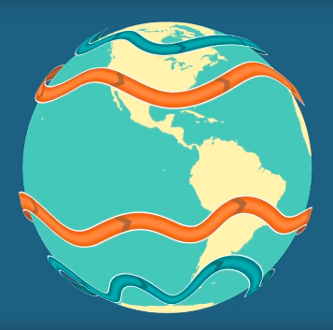
Jet streams are bands of strong wind that generally blow from west to east all across the globe. They impact weather, air travel and many other things that take place in our atmosphere. Learn what causes Earth’s jet stream and find the answer to the blank below by following this link: Jet Stream

Answer 7: On Earth there are four main jet streams: two polar jet streams and two ______ jet streams.

All About Tides!
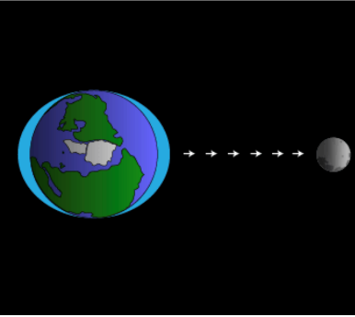
Did you know that the highest tides occur when the moon is new or full? It’s true! Learn all about tides and what causes them by following this link: Tides.

Answer 8: High and low tides are caused by the moon’s _____ pull, which generates what is called the tidal force.

All About Hurricanes!
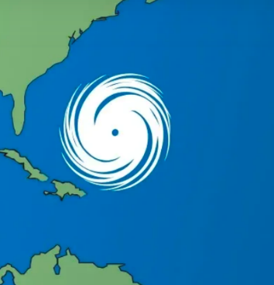
Hurricanes are the most violent storms on Earth. They form near the equator over warm ocean waters. Actually, the term hurricane is used only for the large storms that form over the Atlantic Ocean or eastern Pacific Ocean. What’s the generic scientific term for these storms? Find out the answer to the blank below by following this link: Hurricane

Answer 9: The term hurricane is used only for the large storms that form over the Atlantic Ocean or eastern Pacific Ocean. _____ _____ is the generic scientific term used for these storms, regardless of where they occur.

Answer 1
Answer 2
Answer 3
Answer 4
Answer 5
Answer 6
Answer 7
Answer 8
Answer 9

Answer Key:
- Condensation
- Particle
- Enhanced Fujita
- Heat
- Altocumulus
- Cold front
- Subtropical
- Gravitational
- Tropical Cyclone

Answer 1 |  |  |  |  |  |  |  |  |  | C | O | N | D | E | N | S | A | T | I | O | N
Answer 2 |  |  |  |  |  |  |  |  |  |  |  |  |  |  | P | A | R | T | I | C | L | E
Answer 3 |  |  | E | N | H | A | N | C | E | D |  | F | U | J | I | T | A
Answer 4 |  |  |  |  |  |  |  |  |  |  |  |  |  |  | H | E | A | T
Answer 5 |  |  |  |  |  |  |  | A | L | T | O | C | U | M | U | L | U | S
Answer 6 |  |  |  |  |  |  |  |  |  |  |  |  |  | C | O | L | D |  | F | R | O | N | T
Answer 7 |  |  |  |  |  |  |  |  | S | U | B | T | R | O | P | I | C | A | L
Answer 8 |  |  |  |  |  |  |  |  |  |  | G | R | A | V | I | T | A | T | I | O | N | A | L
Answer 9 | T | R | O | P | I | C | A | L |  | C | Y | C | L | O | N | E

SECRET WORD: Satellite

